* Business Problem

"To identify the key factors impacting sales and profitability in a company and provide actionable insights through a comprehensive analysis of sales and profit data."

This problem statement sets the goal of exploring and analyzing the sales and profit data to uncover patterns, trends, and relationships that can help identify the factors driving sales and profitability. The analysis aims to provide valuable insights that can guide strategic decision-making and improve overall business performance.

* Data Description

The data contains sales and profit data from a fictional retail company called Superstore. The dataset provides a comprehensive overview of the company's sales performance across different product categories, regions, and customer segments. The dataset used for this analysis covers the period from 2014 to 2017.It comprises 9994 records with 24 variables. Prior to analysis, the data underwent a rigorous cleaning process to handle missing values, remove duplicates, and address any anomalies. Relevant variables were transformed, if necessary, to facilitate the analysis.

Variables in the Superstore Dataset:

- Order ID: A unique identifier for each order placed.

- Order Date: The date when the order was placed.

- Ship Date: The date when the order was shipped.

- Ship Mode: The shipping mode for the order (e.g., Standard Class, Second Class, etc.).

- Customer ID: A unique identifier for each customer.

- Customer Name: The name of the customer who placed the order.

- Segment: The customer segment to which the customer belongs (e.g., Consumer, Corporate, Home Office).

- Product ID: A unique identifier for each product.

- Category: The product category to which the product belongs (e.g., Furniture, Office Supplies, Technology).

- Sub-Category: The sub-category of the product (e.g., Chairs, Tables, Phones).

- Product Name: The name of the product.

- Sales: The total sales revenue generated from each order.

- Quantity: The quantity of each product sold.

- Discount: The discount applied to the order.

- Profit: The profit earned from each order.

- Region: The geographical region where the customer is located.

- State: The state where the customer is located.

- Postal Code: The postal code of the customer's location.

- Country: The country where the customer is located.4

* Analysis & Findings

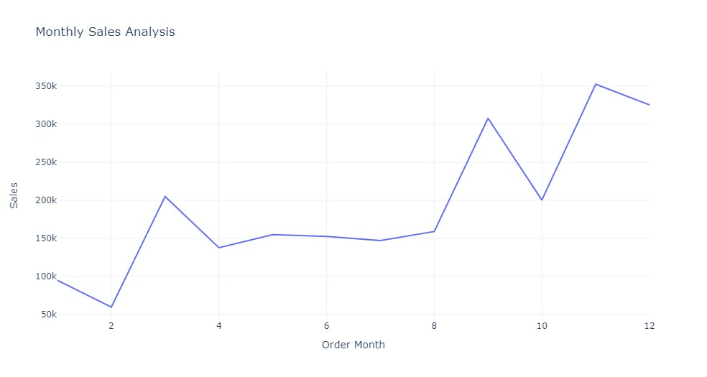

* The above line chart shows monthly sales of the company which shows that the sales were Constant from the month of April to August with an average of 150.32k. There is a clear seasonal pattern in sales, with peak demand occurring during September to December and lower demand during January and February. Sales during the Peak Season contributed to 51.60% of the total revenue.

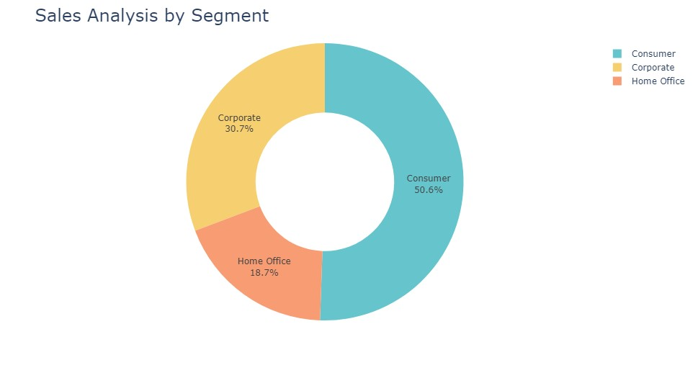

* Consumer Segment contributed the highest share of sales revenue, followed by Corporate Segment and Home Office Segment.

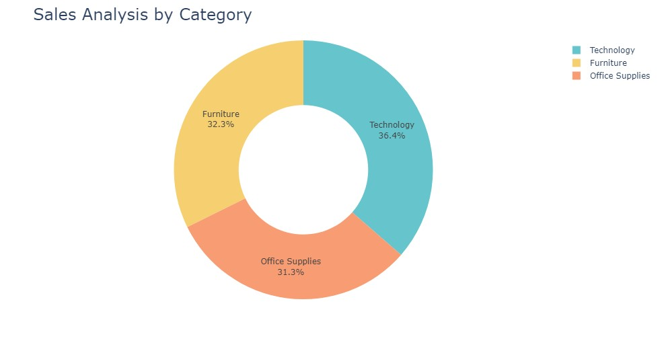

* Category Technology contributed the highest share of sales revenue, followed by Category Furniture and Category Office Supplies.

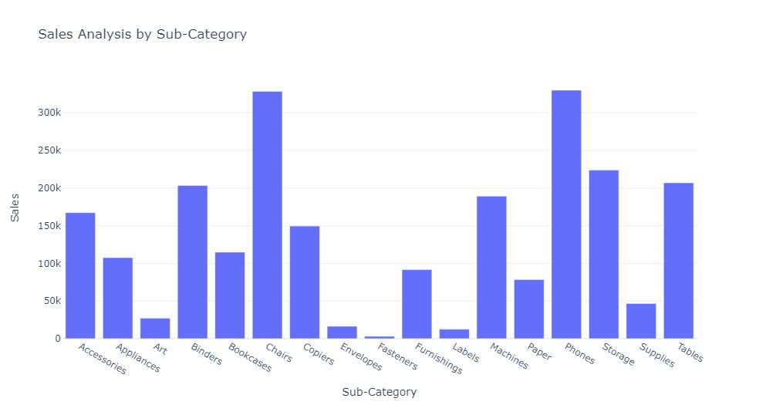

* Chairs and Phones were the highest selling Products.

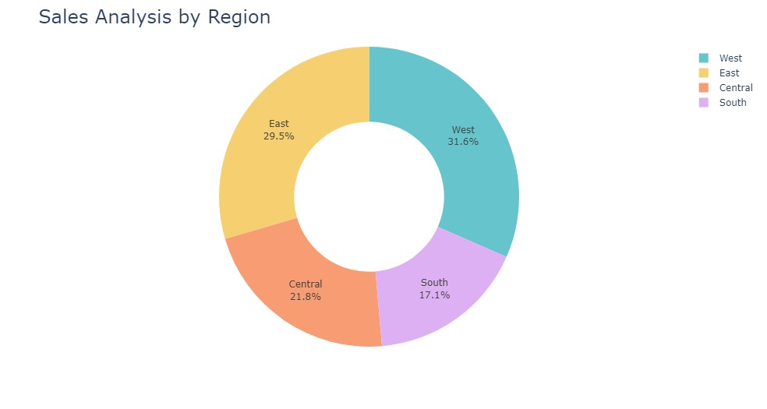

* The above pie chart shows that west region contributed highest share in sales revenue, following by east region and central region and south region.

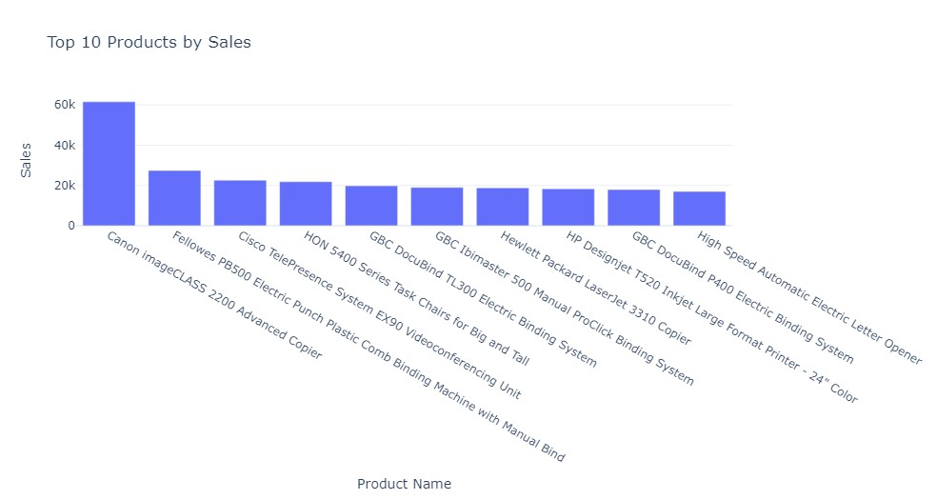

* Canon imageCLASS 2200 Advanced Copier was the highest selling product.

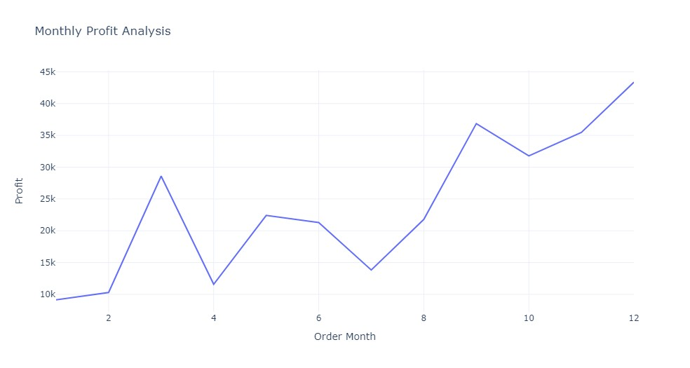

* The above line chart shows monthly Profit of the company. Profit Growth rate from the month of July to September was with an average of 63.35 Percent.

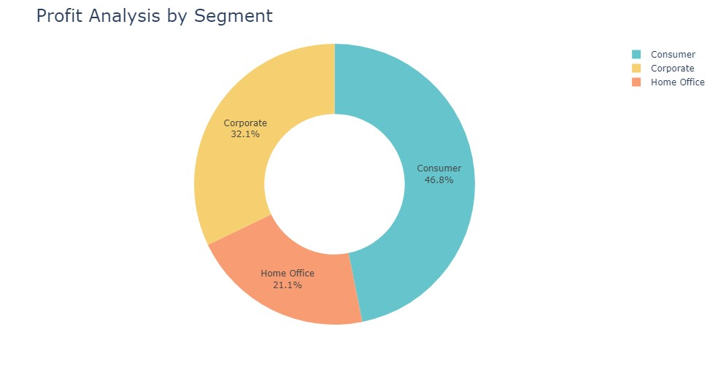

* Consumer Segment contributed the highest share of profit, followed by Corporate Segment and Home Office Segment.

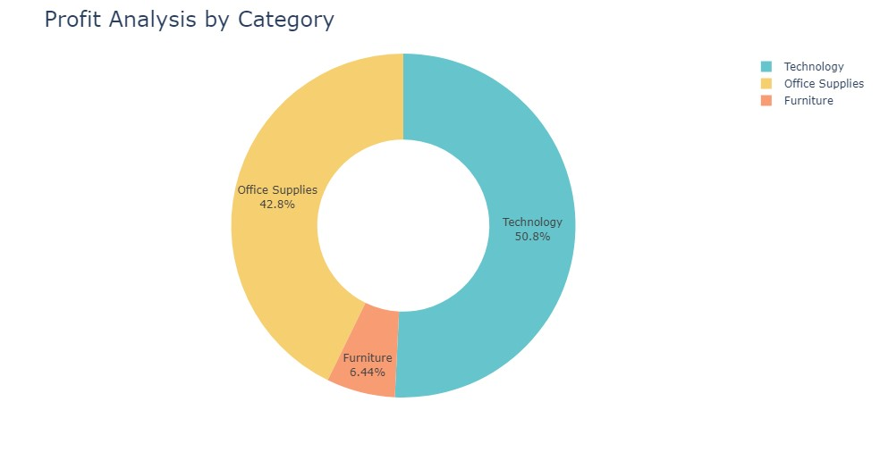

* Category Technology contributed the highest share in Total Profit i.e., 50.8 Percent, followed by Category Office Supplies and Category Furniture.

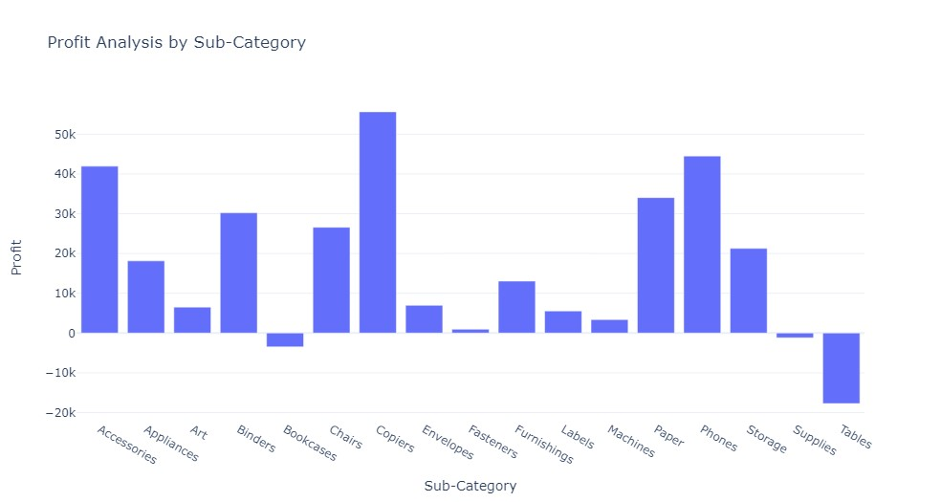

* Copiers were the highest profit generating sub category and Tables were the largest loss-making sub category.

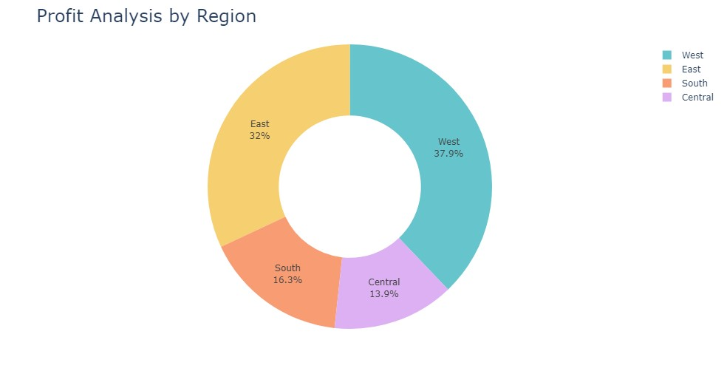

* The above pie chart shows that west region contributed highest share in sales revenue, following by east region and central region and south region.

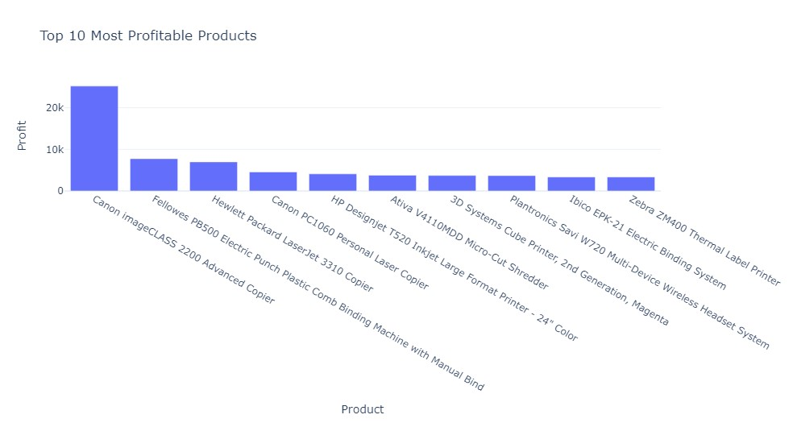

* Canon image CLASS 2200 Advanced Copier was the most profitable product.

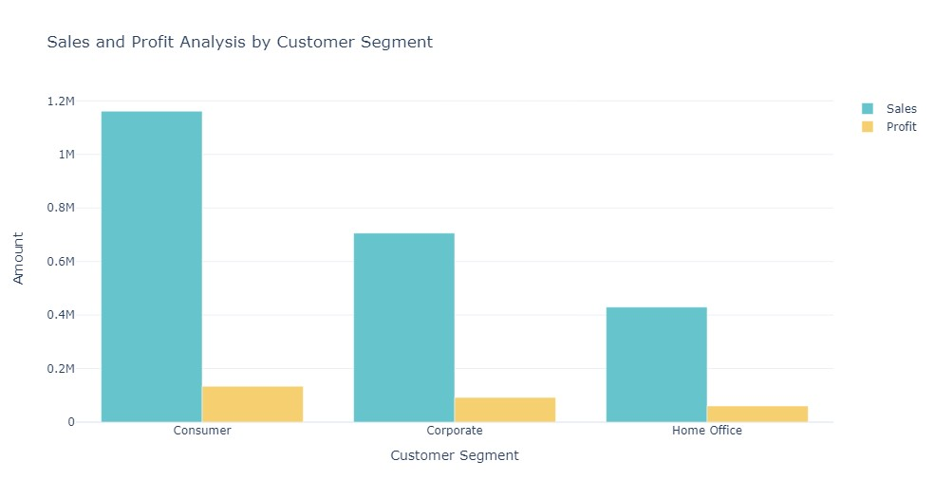

|  |  |
| --- | --- |
| Segment | Sales To Profit Ratio |
| Consumer | 8.65 |
| Corporate | 7.67 |
| Home Offices | 7.125 |

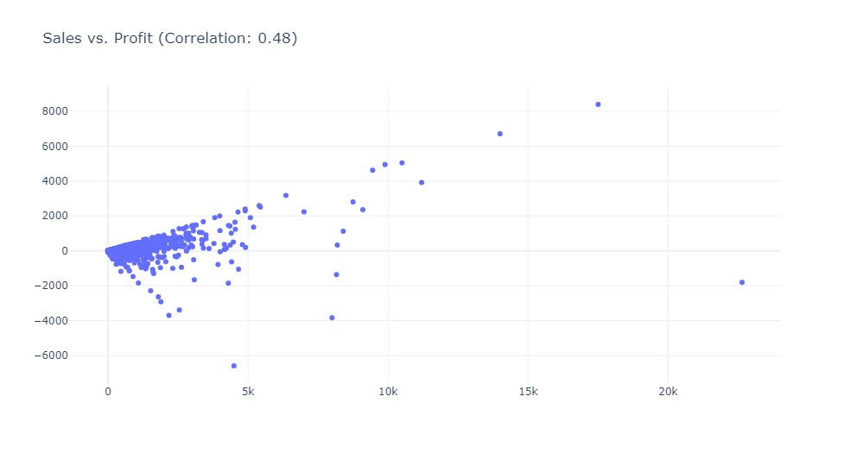

* A correlation coefficient of 0.48 between sales and profit indicates a moderate positive correlation between the two variables.
* The correlation coefficient ranges between -1 and 1, where 1 represents a perfect positive correlation, -1 represents a perfect negative correlation, and 0 represents no correlation. In this case, a correlation coefficient of 0.48 suggests that there is a moderate positive relationship between sales and profit.
* The positive correlation means that as sales increase, there is a tendency for profit to increase as well, and as sales decrease, profit tends to decrease. However, the correlation is not extremely strong, indicating that other factors may also influence profit besides sales alone.
* Recommendation

Building upon the findings of our analysis, we propose the following recommendations to improve sales and profitability:

1. Allocate additional resources and marketing efforts to promote and enhance the performance of Chairs and Phones
2. Optimize marketing strategies by identifying and targeting the most profitable customer segments.
3. Develop seasonal marketing campaigns to capitalize on peak demand periods and maximize revenue.
4. Continuously monitor and analyze sales and profit data to identify emerging trends, customer preferences, and areas for improvement.

* Conclusion
* In conclusion, our sales and profit analysis EDA has provided valuable insights into the factors impacting sales revenue and profitability. By leveraging these findings and implementing the recommended strategies, Superstore can enhance its competitive position, optimize resource allocation, and ultimately drive sustainable growth and profitability. It is important to revisit and update this analysis periodically to adapt to changing market conditions and ensure continued success.